Graph Interpretations
- DHARMa Residual Plots
- Complementary Log-Log
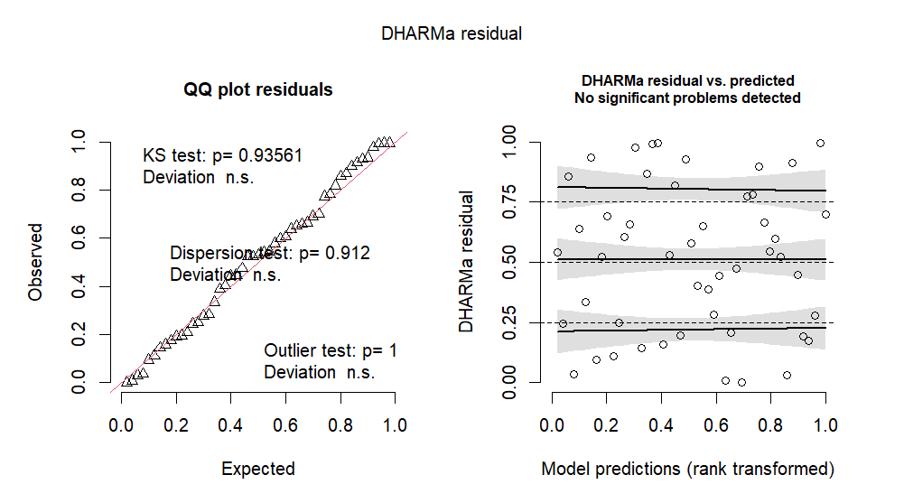
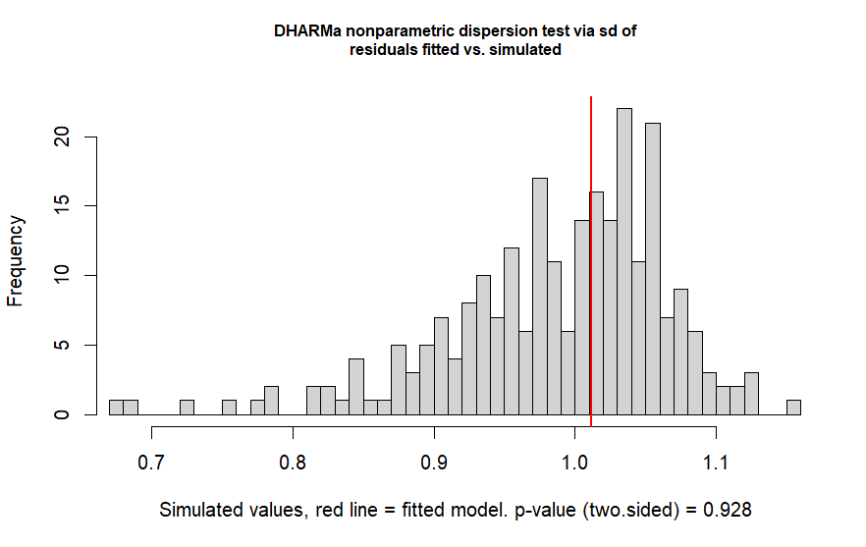

- Logit
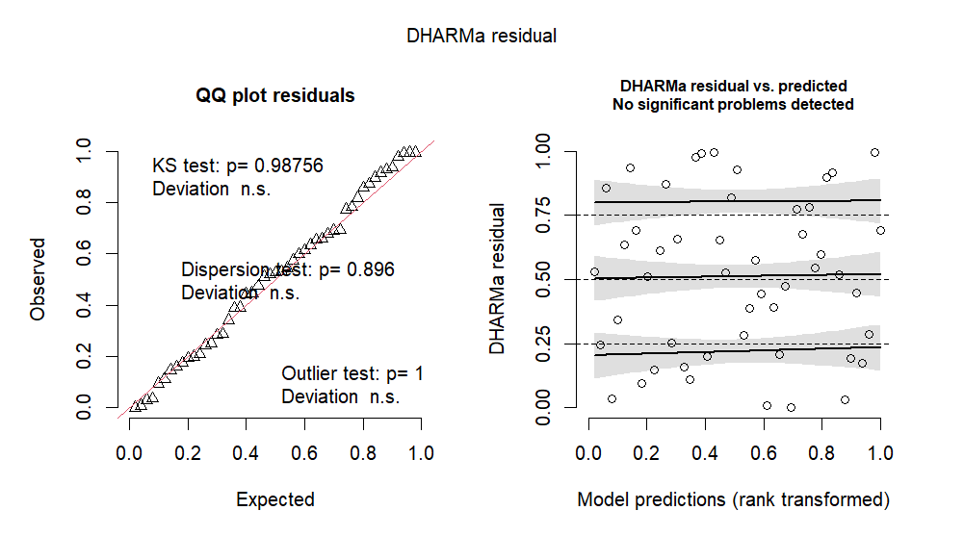

- Log-Log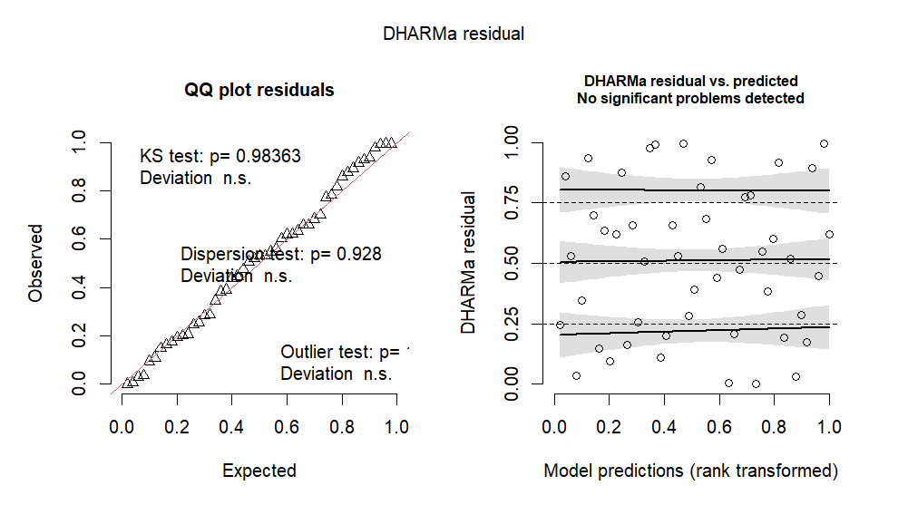
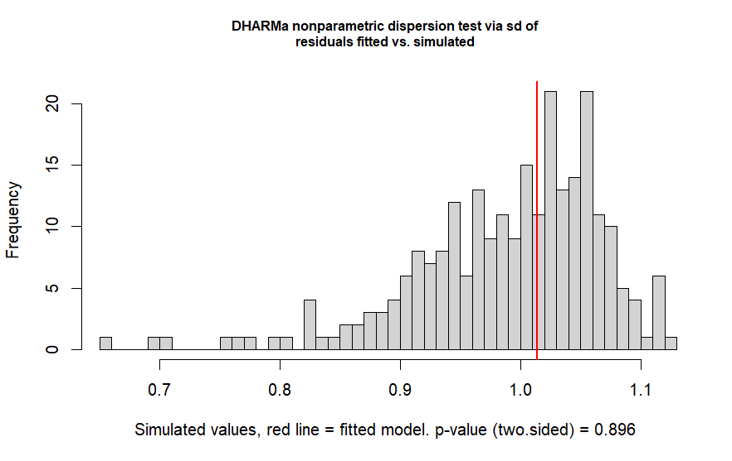

- Probit
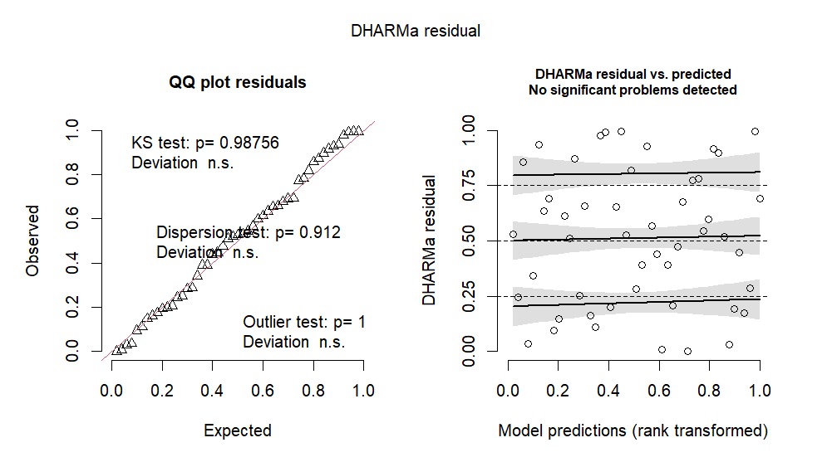

Interpretation of DHARMa Residuals (Complementary Log-Log):
To begin with, the QQ Plot verifies whether the DHARMa residuals follow a Uniform (0,1), thus we compare the expected uniform quantiles to the observed residual quantiles. As the points lie very close to the 45-degree line, and the Kolmogorov-Smirnov test p-value is 0.9836 (for the complementary log-log link), we fail to reject the null hypothesis and thus have no evidence that the residual distribution deviates from uniformity. Furthermore, no influential outliers were detected.
The DHARMa Residuals vs Predicted Plot does not reveal any systematic pattern, so the model does not appear to miss higher-order or interaction effects. Finally, the dispersion of the data’s residuals on the DHARMa Dispersion Histogram provides no evidence of over or under-dispersion, which is further supported by the large p-value (0.928) of the formal dispersion test.
To conclude, the complementary log-log model appears to fit the data adequately, yet the explanatory Stroop-score variables do not significantly predict inattentional blindness.

- Predicted Probability of seeing the Gorilla
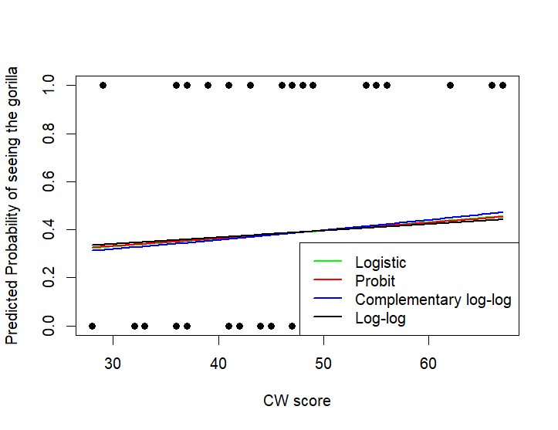
Interpretation:
The predicted probability curves for all four link functions are almost flat and extremely similar, demonstrating that the Stroop CW score has little to no influence over the probability of an individual noticing the gorilla. Moreover, the observed binary response shows no evident relationship with the CW predictor variable. Consequently, these visual results support the formal statistical tests which indicated that Stroop scores do not significantly predict inattentional blindness.

